Apache Spark is a distributed data processing engine designed for
- Big data processing
- High speed analysis
- Batch + streaming + ML + SQL(mysql or other database ) in one platform
Features
- In memory processing faster than disk based memory.
- Distributed in different machine or nodes.
- Fault tolerance
- Multi language : python, java (Scala) , R language

If we want to do Apache spark python provided third party library PySpark.

Features | Pandas | NumPy | Dask | PySpark
Distributed | No | No | Limited | Full
Speed | Slow | Fast | Fast | Very fast
Streaming | No | No | No | Support
ML | No | No | No | Yes

Data -- 15 to 20 GB
Data engineering pine line
Stream of data
ML on large data set LLM
Production big data system

Spark modules

Spark core : distributed execution engine
Spark SQL it provide SQL query features
Spark streaming real time data processing
Structured stream modern streaming API
MLib Machine leaning
GraphX Gparph processing

Open the folder and write the below command to create python virtual environment folder
py -3.10 -m venv spark-evn
activate virtual environment folder

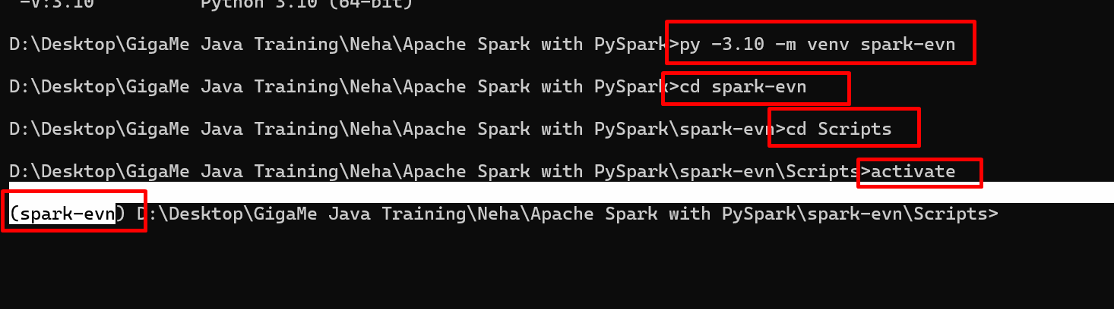

Now we will install pyspark module

python -m pip install pyspark==3.5.1

RDD modules
Resilient distributed dataset
RDD is immutable, distributed and fault tolerant low level data structure part of Apache spark. This is a part of Apache spark core modules.

